Twitter Sentiment Analysis

Obtaining the required libraries

Creating the twitter connection

Obtaining first set of tweets

Obtaining second set of tweets

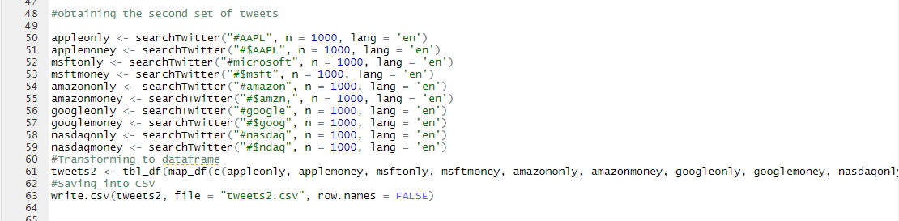

Textual preprocessing for twitter dataset1

Creating the term document matrix, word frequency bar plot and word cloud for twitter dataset 1

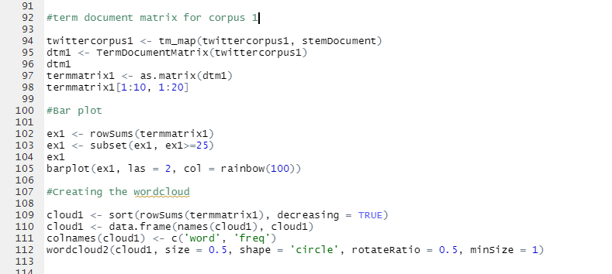



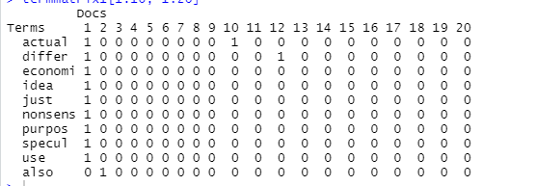

Textual preprocessing for twitter dataset2

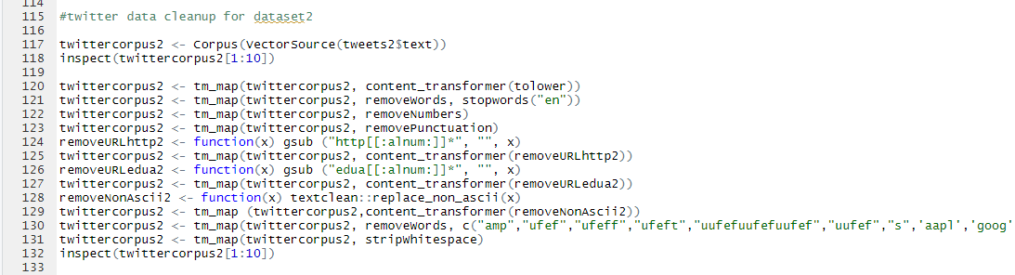

Creating the term document matrix, word frequency bar plot and word cloud for twitter dataset 2

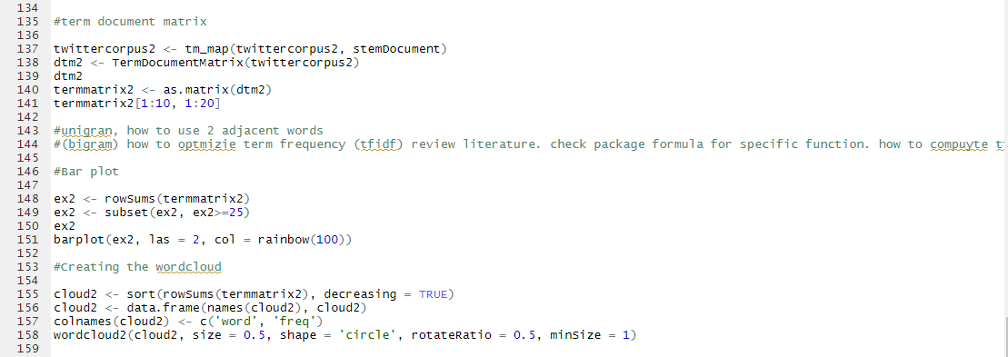

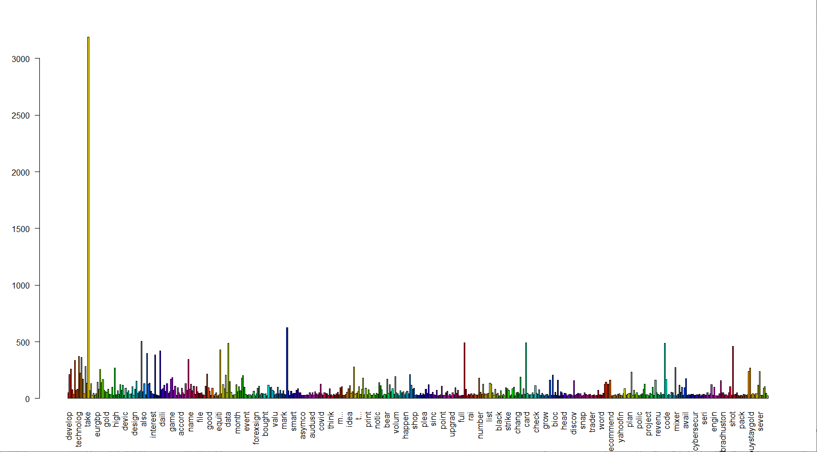

Obtaining sentiment analysis for the cleaned-up twitter databases

